Gen AI Archi Tech
- YOU ARE A System Builder, not AI USER
- Think how AI like Chat GPT, Claude, Grok all works
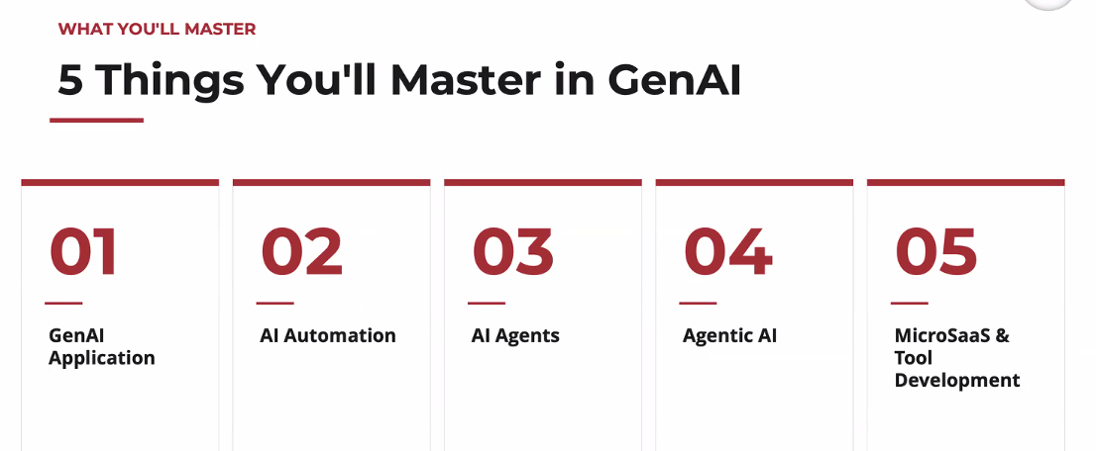

Gen AI Application – Its intelligence
AI Automation – Starting to End, set a automation (Example : Bus)
AI Agent – It’s a Tool (complete list of task) – (Example: It decides bus/train, how to reach)
Agentic AI – Goal Oriented (Set a Goal, list of AI Agent to achieve the goal)
MicroSAAS Tool –
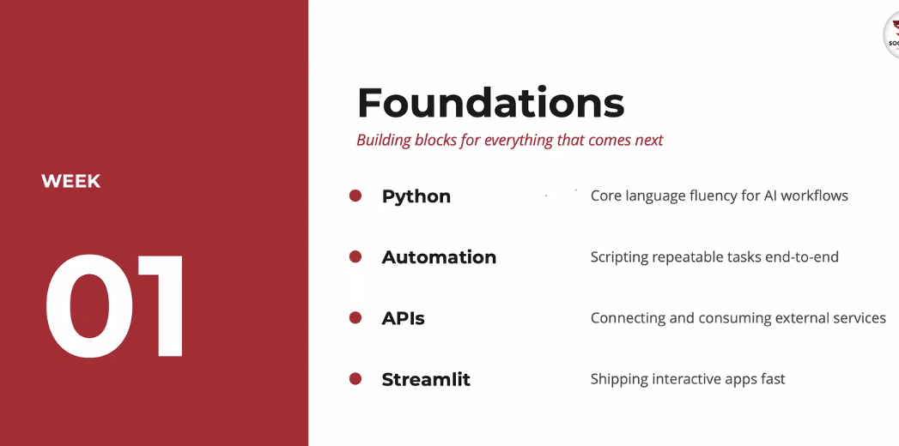
Why Python? – AI friendly tool
API – communicating two software is API (Back end, like car engine)
Streamlit – It is front End like Car’s body)
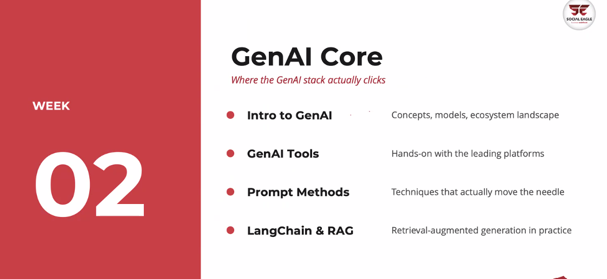

Gen AI - using LangChan how application being developed

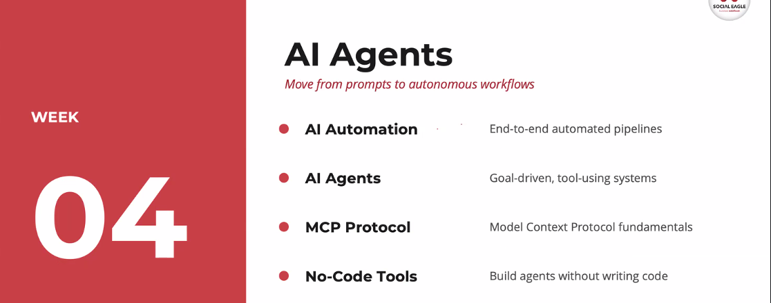

No Code Tools –

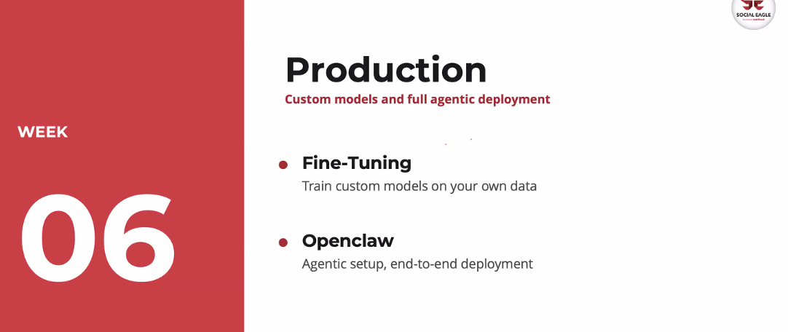

Bro, I joined session bit late,

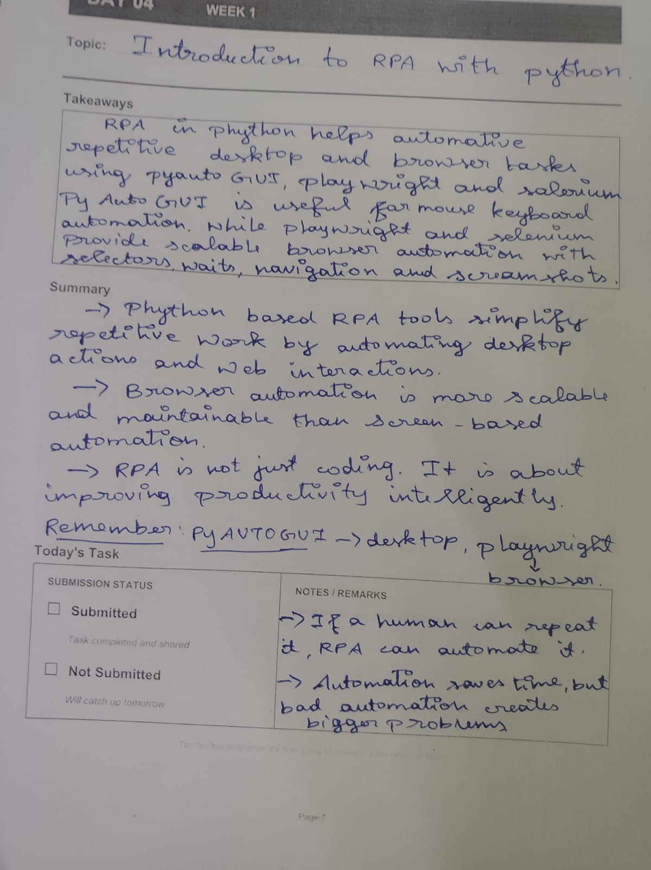

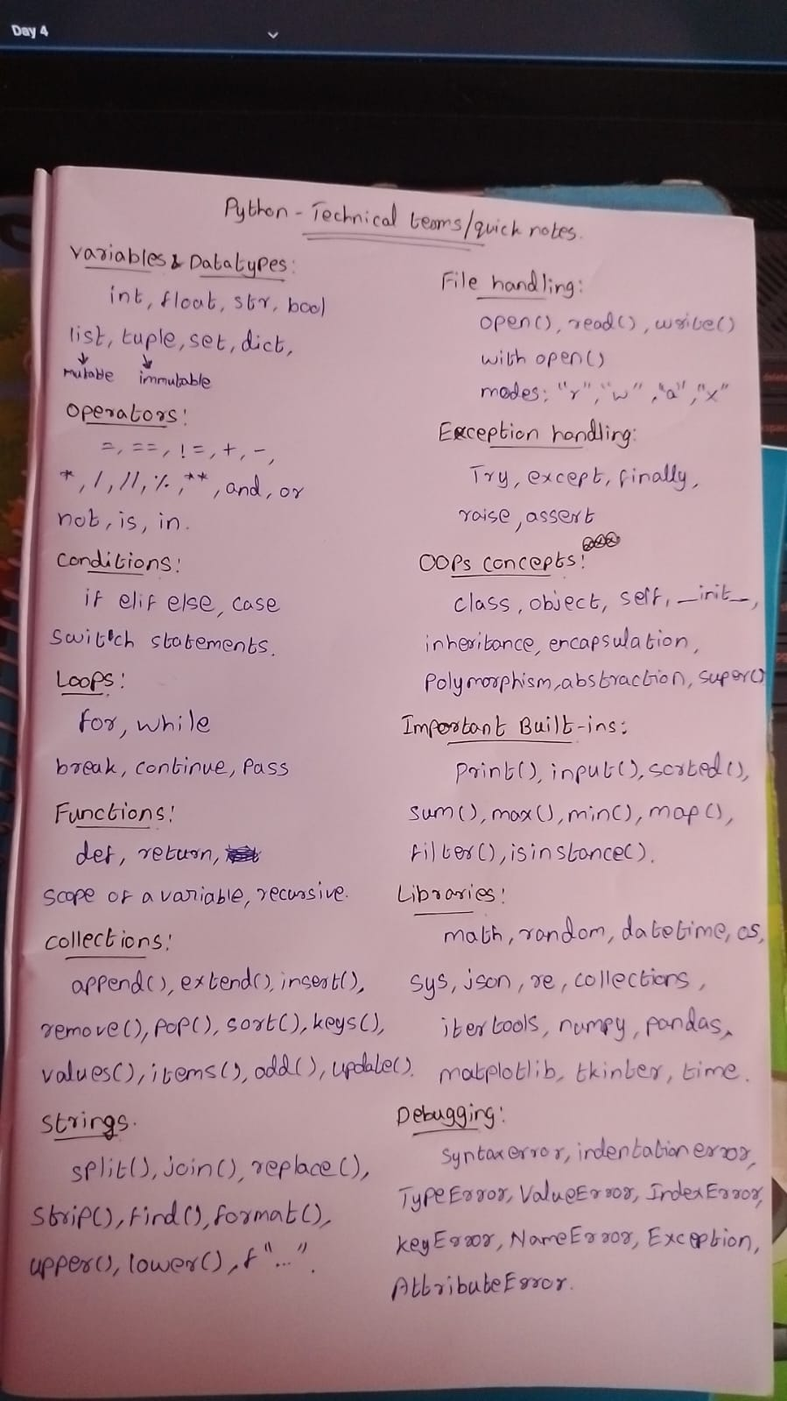
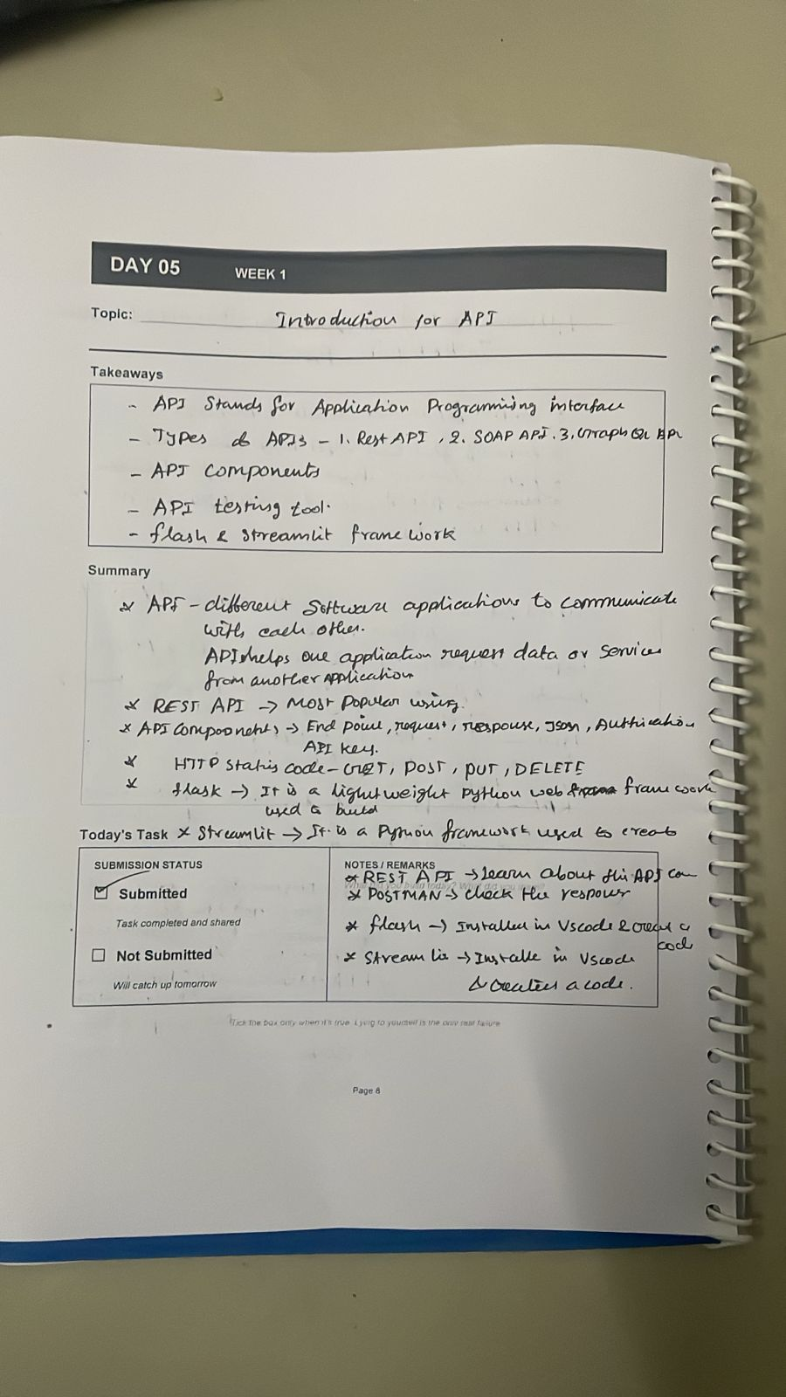
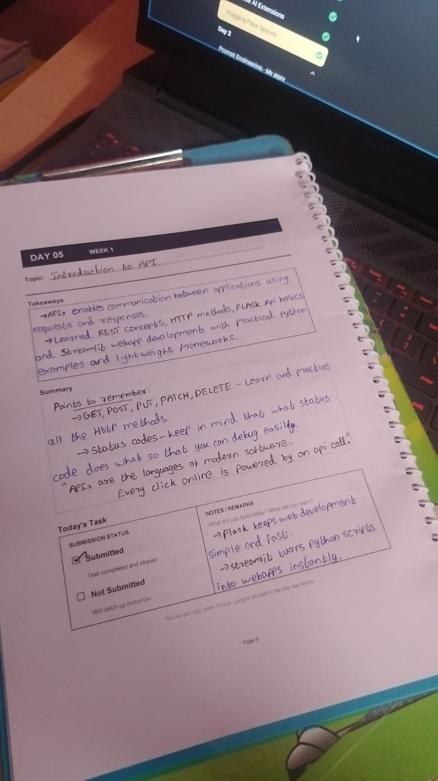
# Doubt Clearing Session Notes — 16-05-2026

## 1. What is an API?

API stands for **Application Programming Interface**.

An API is a way for two software systems (or machines/applications) to communicate with each other.

### Simple Flow

* A **Client** sends a request.
* A **Server** receives the request.
* The server processes it.
* The server sends back a response.

### Real-life Example

Think of a restaurant:

* You = Client
* Waiter = API
* Kitchen = Server

You give the order to the waiter (request), the waiter takes it to the kitchen, and the kitchen sends back the food (response).

### Technical Example

When a frontend application sends:

```python
GET /users
```

The backend server may return:

```json
[
{
"id": 1,
"name": "John"
}
]
```

---

# 2. Flask API

Flask is a lightweight Python framework used to create web applications and APIs.

It is commonly used because:

* Easy to learn
* Minimal setup
* Good for beginners
* Fast development

### Basic Flask API Example

```python
from flask import Flask

app = Flask(__name__)

@app.route("/")
def home():
return "Hello World"

if __name__ == "__main__":
app.run(debug=True)
```

### What happens here?

* `Flask(__name__)` → creates Flask application
* `@app.route("/")` → creates an endpoint
* `home()` → function executed when endpoint is called
* `app.run()` → starts the server

When you run this file:

```bash
python app.py
```

You may see:

```bash
Running on http://127.0.0.1:5000
```

This URL is your API URL.

---

# 3. Types of APIs

- REST API
- GRAPH QL
- SOAP API

## REST API

REST = Representational State Transfer

This is the most commonly used API type.

### Features

* Uses HTTP methods
* Lightweight
* Fast
* Mostly returns JSON data
* Easy to integrate

### Example

```python
GET /students
POST /students
```

### Used In

* Web applications
* Mobile apps
* Automation systems
* Backend services

---

# HTTP Methods in REST API

HTTP methods define what action we want to perform.

---

## A) GET

Used to retrieve/fetch data.

### Example

```python
GET /users
```

Meaning:
→ “Give me all users.”

### Flask Example

```python
@app.route("/users", methods=["GET"])
def get_users():
return {"users": ["John", "Sam"]}
```

---

## B) POST

Used to create new data.

### Example

```python
POST /users
```

Meaning:
→ “Create a new user.”

### Flask Example

```python
@app.route("/users", methods=["POST"])
def create_user():
return {"message": "User created"}
```

---

## C) PUT

Used to update existing data completely.

### Example

```python
PUT /users/1
```

Meaning:
→ “Update user with ID 1.”

### Flask Example

```python
@app.route("/users/<id>", methods=["PUT"])
def update_user(id):
return {"message": f"User {id} updated"}
```

---

## D) DELETE

Used to remove data.

### Example

```python
DELETE /users/1
```

Meaning:
→ “Delete user with ID 1.”

### Flask Example

```python
@app.route("/users/<id>", methods=["DELETE"])
def delete_user(id):
return {"message": f"User {id} deleted"}
```

---

# 5. Postman Tool — Complete Usage Process

Postman is a tool used to test APIs.

It helps developers send requests to APIs without writing frontend code.

---

# Step-by-Step Postman Workflow

## Step 1 — Create Flask API

Example:

```python
from flask import Flask

app = Flask(__name__)

@app.route("/")
def home():
return {"message": "Hello API"}

if __name__ == "__main__":
app.run(debug=True)
```

Save as:

```bash
app.py
```

---

## Step 2 — Run the Flask File

Open terminal:

```bash
python app.py
```

Output:

```bash
Running on http://127.0.0.1:5000
```

This means:
Your API server is running locally.

---

## Step 3 — Open Postman

Open the Postman application.

You will see:

* URL input box
* HTTP method dropdown
* Send button
* Response section

---

## Step 4 — Paste API URL

Paste:

```bash
http://127.0.0.1:5000
```

in the URL box.

---

## Step 5 — Select HTTP Method

From dropdown select:

* GET
* POST
* PUT
* DELETE

depending on API.

For home route:
Use `GET`

---

## Step 6 — Click Send

Press the **Send** button.

---

## Step 7 — Check Response

You will see response below.

Example:

```json
{
"message": "Hello API"
}
```

You can also see:

* Status code
* Response time
* Response body

---

# Sending POST Request in Postman

Suppose API:

```python
from flask import Flask, request

app = Flask(__name__)

@app.route("/user", methods=["POST"])
def add_user():
data = request.json
return {
"name": data["name"]
}
```

---

## In Postman

### 1. Select POST method

### 2. URL

```bash
http://127.0.0.1:5000/user
```

### 3. Go to Body Tab

Select:

```text
Body → raw → JSON
```

### 4. Enter JSON Data

```json
{
"name": "Rahul"
}
```

### 5. Click Send

Response:

```json
{
"name": "Rahul"
}
```

---

# Important Sections in Postman

| Section | Purpose |
| --------------- | ---------------------- |
| URL Box | API endpoint |
| Method Dropdown | GET/POST/PUT/DELETE |
| Headers | Additional information |
| Body | Data sent to server |
| Response Panel | Shows API response |

---

# 6. HTTP Status Codes

Status codes tell whether the request succeeded or failed.

---

# A) 2xx — Success

Request completed successfully.

| Code | Meaning |
| ---- | ---------- |
| 200 | OK |
| 201 | Created |
| 204 | No Content |

### Example

```python
return {"message": "Success"}, 200
```

---

# B) 3xx — Redirection

Client must take additional action.

| Code | Meaning |
| ---- | ------------------ |
| 301 | Moved Permanently |
| 302 | Temporary Redirect |

Example:
Website URL changed.

---

# C) 4xx — Client Errors

Problem from client side.

| Code | Meaning |
| ---- | ------------ |
| 400 | Bad Request |
| 401 | Unauthorized |
| 403 | Forbidden |
| 404 | Not Found |

### Example

```python
return {"error": "User not found"}, 404
```

---

# D) 5xx — Server Errors

Problem from server side.

| Code | Meaning |
| ---- | --------------------- |
| 500 | Internal Server Error |
| 502 | Bad Gateway |
| 503 | Service Unavailable |

### Example

Server crashes due to code issue.

---

# 7. Authentication vs Authorization

These are security concepts used in applications and APIs.

---

# A) Authentication

Authentication means:

> Verifying WHO the user is.

### Example

Entering:

* Username
* Password
* OTP
* API Key

### House Example

Giving the correct key to enter the house.

So the system checks:

“Are you a valid user?”

### Common Authentication Methods

* Username & Password
* JWT Token
* OAuth
* API Keys

---

# B) Authorization

Authorization means:

> Verifying WHAT the user is allowed to access.

After authentication, system checks permissions.

### House Example

After entering the house:

* Hall access allowed
* Bedroom access denied

### In Applications

| User Role | Permission |
| --------- | ---------------- |
| Admin | Full access |
| Employee | Limited access |
| Guest | Read-only access |

---

# Authentication vs Authorization — Difference

| Authentication | Authorization |
| ----------------- | ---------------------------- |
| Verifies identity | Verifies permissions |
| “Who are you?” | “What can you access?” |
| Happens first | Happens after authentication |
| Login process | Access control |

---

# Weekend Tasks

## 1. Practice Python Scripts in RPA Automation

Topics to practice:

* File handling
* Loops and conditions
* Exception handling
* Automation scripts
* Mouse & keyboard automation
* Browser automation

### Tools

* PyAutoGUI
* Playwright

---

## 2. Complete This Week’s Assignments

### A) Python Basics Programs

Practice:

* Loops
* Functions
* Lists
* Dictionaries
* OOP basics

---

### B) Automation

Practice:

* Mouse automation
* Keyboard automation
* Browser automation
* Web scraping basics

Libraries:

* PyAutoGUI
* Playwright

---

### C) API — Flask Endpoints (`app.py`)

Create APIs using:

* GET
* POST
* PUT
* DELETE

Practice returning:

* JSON responses
* Status codes

---

### D) Streamlit Quiz App

Streamlit project ideas:

* Multiple-choice quiz
* Score calculation
* Timer
* User input forms

---

# Important Revision Points

* API = communication between client and server
* Flask is used to build APIs
* REST API is most commonly used
* HTTP methods:

* GET → fetch
* POST → create
* PUT → update
* DELETE → remove
* Postman is used for API testing
* Status codes indicate request result
* Authentication = identity verification
* Authorization = permission control
RPM → Requests Per Minute
One minute-ku evlo request send panna mudiyum.
Example: 60 RPM means 1 minute-la 60 API calls.
TPM → Tokens Per Minute
One minute-la evlo text tokens process panna mudiyum.
Tokens means words split into small parts.
Example:
- “Hello world” = around 2 tokens
- Large paragraph = many tokens

